Karibu Kenya: Culture and Agriculture in Africa
PLNT 4790/5790-01 (CRN 15297 & 15298), 2 cr (Last day to register October 21, 2011)
Course Dates: December 9-22, 2011 - Limited Enrollment of 18 Students

Instructors: Dr. Dave Wilson, Emeritus Faculty, Director of College of Ag KEEPS Program
Dr. Amy McLean, Assistant Professor, Animal Science Department

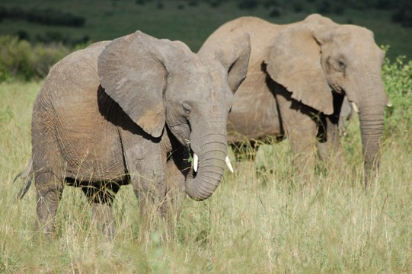
Native Kenyan Guide & Instructor:
Dr. Emmanuel Omondi, Ph.D. Post-Doc
Director, Manor House Agricultural Center, Kitale, Kenya
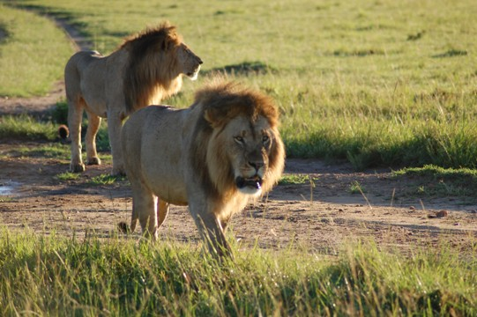

Tentative Schedule of Course Activities

Friday, Dec 9: Evening departure from Denver, OR morning of December 10
Note: Either 9th or 10th of December are both suitable optional departure dates from Denver. Neither interferes with the program. Earlier departure simply gives people more time to rest.

Saturday, Dec 10: Arrival in Nairobi
- Check in at Hotel (Eshel Gardens of Diane and Ibrahim Omondi)
- Dead day – visit Giraffe center, Karen Blixen Museum, Diane and Ibrahim Omondi’s commercial ‘organic’ greenhouses.

Sunday Dec 11:
- Masai market to purchase souvenirs, Nairobi National park or animal orphanage (zoo) to play with cheetahs and lions, Mamba village to play with crocodiles, Nairobi National Museum, etc. Carnivore Restaurant for dinner to try out all kinds of game meat (ostrich, crocodile, goat, etc.) Cost about $25 per person. Google for more information, e.g. http://www.africanmeccasafaris.com/kenya/nairobi/excursions/carnivore.asp

- Monday Dec 12: SACDEP – Kenya: Sustainable Agriculture community development program - http://sacdepkenya.org/, COSDEP – Kenya: Community Sustainable Development Empowerment Program, http://cosdep.wordpress.com/about/ or http://www.microaid.org/?q=content/community-sustainable-development-empowerment-program , RODI – Kenya: Resource Oriented Development Initiative, http://www.rodikenya.org/, G-BIACK – Grow Biointensive Agriculture Centre of Kenya, http://gbiack.blogspot.com/

Tuesday Dec 13: The Great Rift Valley, Flamingo Farm (Cut-Flower-for Export, water conservationist) along Lake Naivasha, Hells Gate Wildlife Refuge, Naivasha, Hotel in Kericho

Wednesday Dec 14: Kericho (Finlays) Tea Estates in Kericho, Arrival in Kitale, Manor House Agricultural Center (MHAC) - www.mhacbiointensive.org Dinner and bed at MHAC

Thursday Dec 15: Tour of MHAC, Gardening activities at MHAC (animal draft power, double digging, composting, Bio-intensive agriculture, etc)

Friday Dec 16: Visit two projects initiated by MHAC graduates and two community mini-training centers initiated by MHAC; Recreation at the Kitale Club (swimming, golf, gym, leisure, food & beverages)

Saturday Dec 17: Visit VI-Agroforestry project in Kitale, Travel back to Nairobi (by air); Stay at Eshel Gardens

Sunday Dec 18: Travel to Masai Mara National Park in Narok, One evening game drive at Masai Mara, Dinner and bed at Masai Mara

Mon Dec 19: All day game drives at Masai Mara, Breakfast, Lunch and Dinner at Masai Mara

Tues Dec 20: One last morning game drive at Masai Mara, Travel Back to Nairobi, Masai Market in Westland, Village Market (depending on arrival time), Departure back to USA on Dec 20-21. Remember we have to drive from Masai Mara (leaving around noon) to Nairobi (6 hours) so flights on the 20th should be booked for late evening or anytime on the 21st.

Wed Dec 21: If you are flying out a day later than early departures, your stay will be extended at Eshel Gardens and you will have a last chance to visit the Masai Markets in the morning, with plenty of time to make your flight. Your arrival in the U.S. will be on Thursday December 22nd Friday December 23rd for late departures.

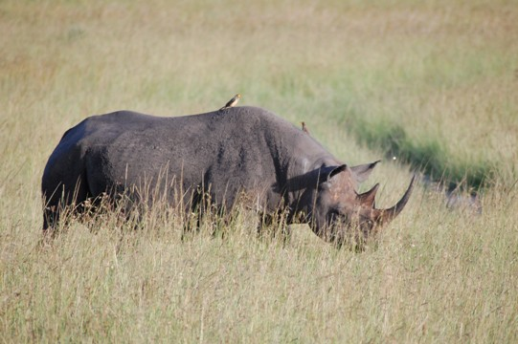
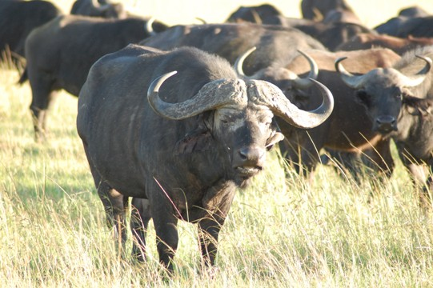

The entire cost of this trip is estimated at under $3,500.00, including airfare, game safaris, tuition (in-state), souvenirs, room & board and travel in Kenya. Specific itemized costs will be provided to students who attend the organizational meetings. A valid passport and immunization records are required. Scholarships are available up to $3,500.00 to defer student costs. For a better understanding of the trip see the Karibu student essays at
http://www.uwyo.edu/KEEPS

An Informational & Organizational Meeting was held September 13, 2011. If you missed it we will have a second one next Tuesday at 5:15 in Room 4040 of the New Ag Building
Meetings for registered students will be held on October 20th, November & December.

